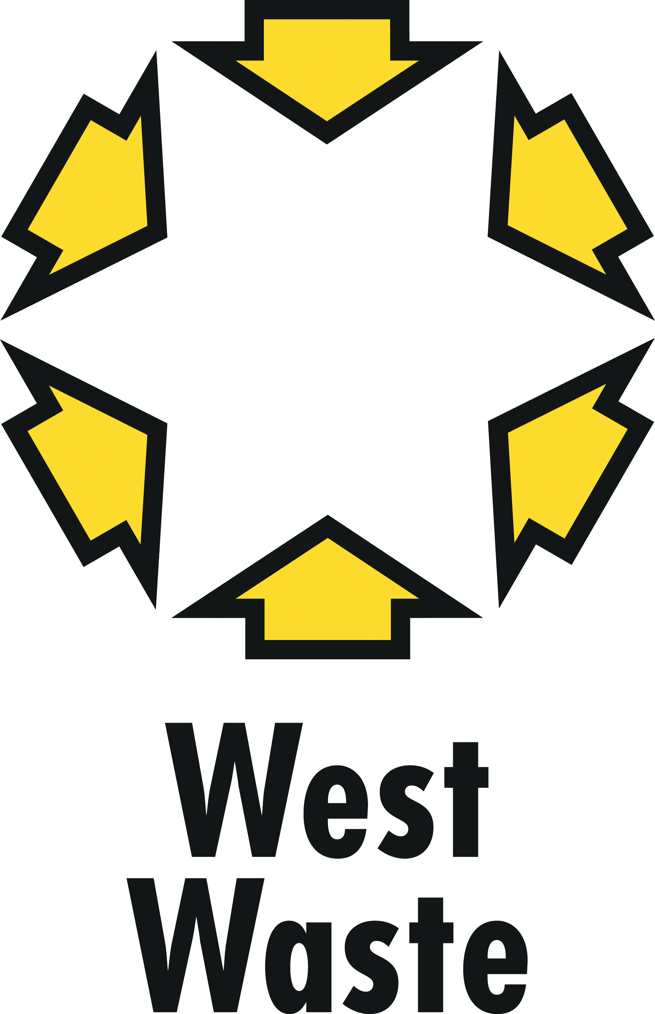
Appendix 1

West London Waste Authority Business Plan 2017-2020
- updated March 2019

Section 1: Role and Services

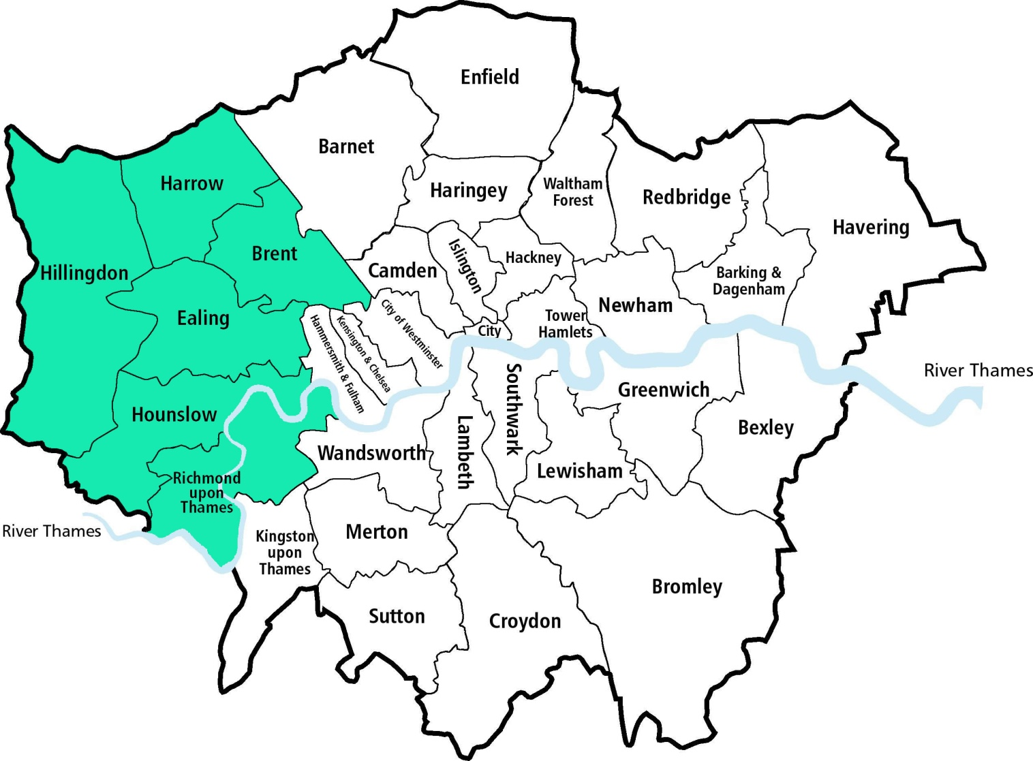
Since the creation of West London Waste Authority in 1986 we have provided waste treatment and disposal services to the six boroughs of Brent, Ealing, Harrow, Hillingdon, Hounslow and Richmond upon Thames.

Our statutory duties are to arrange:
- Facilities for the receipt and recycling, treatment or disposal of the waste which is collected by the boroughs;
- The provision of Household Re-use and Recycling Centres (HRRCs) and the transport and disposal of the waste received at those sites; and
- The storage and disposal of abandoned vehicles, which are removed by the boroughs.

By undertaking these statutory duties efficiently, in partnership with the boroughs and other stakeholders we will deliver our purpose to be leaders in treating waste as a valuable resource.

Partnership

WLWA’s structure includes a number of mechanisms to ensure close working with our stakeholders. Meetings and boards give all partners formal opportunities to provide input, monitor and challenge progress of the key activities contained in this business plan and risks and opportunities as they arise.

- Borough Partnership Meetings: Held 5 times a year prior to the Authority meetings with elected members these will support progress of projects, review and refresh the action plans within the JMWMS and review Authority reports.

- Project Boards: These are formed to support the delivery of new infrastructure. Frequency and composition reflect the needs of the project up to a maximum of one per month.

- Contract Meetings: Are held with all contractors to review performance and identify efficiencies and explore opportunities. For the Authority’s largest contract a Stakeholder Liaison Committee is held with senior management from both sides to discuss projects, opportunities and service provision at a strategic level.

Strategy

The joint municipal waste management strategy (JMWMS) agreed by WLWA and the six boroughs provides the vision for the Authority’s service delivery to achieve our purpose. It is the foundation for this business plan.

The current strategy was first agreed in 2006 with an addendum agreed in 2009 as part of the preparations for the residual waste services procurement and expires in 2020. The most recent review of the action plans was completed in September 2017.

During the period of the current JMWMS the amount of waste produced per head of population has reduced
- Waste minimisation has resulted in less waste being received by the Authority
- Increased recycling and composting (collected and at HRRCs) has resulted in greater complexity of service
- Population has increased

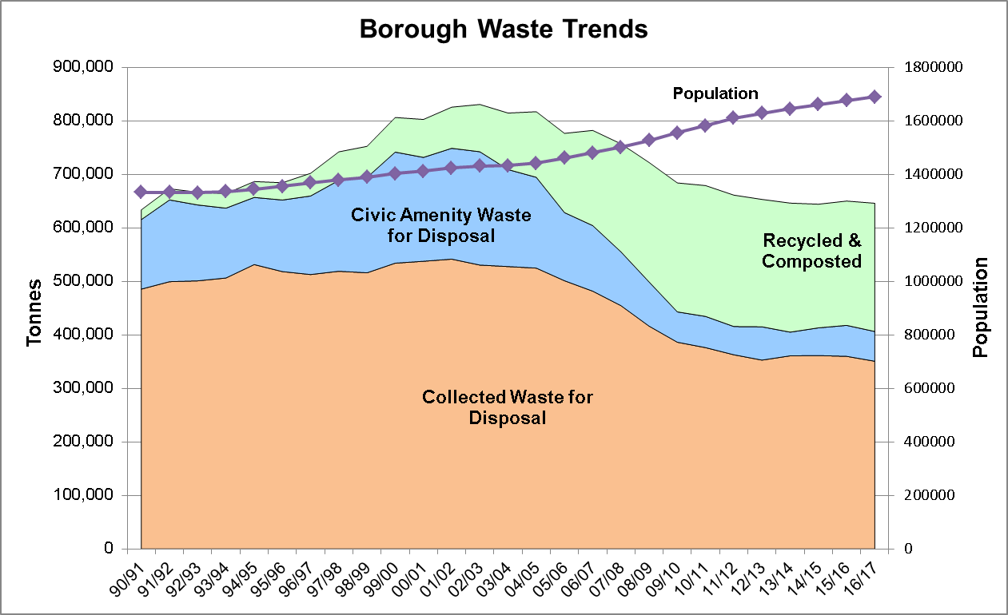

Core Services

- Waste Minimisation – the Authority has combined prevention and re-use activity with recycling to provide simple, strong messages aimed at behaviour change which will increase sustainability and reduce cost. This is in line with circular economy and sustainable development goals.
- Household Reuse and Recycling Centres – the HWRCs and transfer stations remain very important facilities for the residents of west London, giving householders and local traders the ability to sort waste, thus prioritising reuse, recycling and composting over treatment and disposal. Interim arrangements were put in place in 2012 for the boroughs to continue to provide the sites.
- Recycling – the Authority is developing systems which will enable joint procurement of recycling materials to bring economies of scale. We are prioritising the value extraction of recycling from all of our waste streams and improving the quality of recycling materials offered to market.
- Composting / Anaerobic Digestion – New contracts for the treatment of organic waste have been put in place from April 2018.
- Energy from Waste – the Authority has in place two major contracts which ensure that for the contract duration 96% of residual waste is diverted from landfill.

Section 2: 2018/19 in review

Corporate Governance – The Authority’s membership changed in 2018 with four new members joining following Council elections in May. One independent members assists with the audit commitee twice per year. There has been ongoing project development, consultation and engagement with the boroughs throughout the year. Four internal audit reviews have been completed providing assurance about the Authority’s key areas of control and they reflect the strong governance policies and procedures that have been put in place.

Organisational review – The management structure combines contracts and operations management to ensure we lead best practice and continuous improvement through all of our services. A new projects team is delivering strategic joint projects to offer synergy and efficiency to the constituent boroughs. Continued development of project management skills in the waste minimisation team and the ongoing management improvements at Twyford will assist delivery of the challenges ahead of us.

Financial Control – The Authority has in place a solid financial framework and strong forward financial planning. Both internal and external audits provide assurance of effective financial control and robust systems and processes in operation. There is a rigorous annual budgeting process and regular scrutiny through budget monitoring and reporting to the Authority. Longer term financial planning also continues to show how the major contracts reduce the impact of price inflation over the long term and support future infrastructure investment.

Contracts and Operations – All of the Authority’s contracts continued to deliver good value for money and have met service requirements in year. Improvements at the transfer stations have resulted in high operating hours at Severnside Energy Recovery Centre . The new long term food waste treatment service is producing renewable energy and will create new infrastructure for gas powered vehicles. The organic and transport contracts have mobilised and operate well. At the Authority’s Twyford Waste Transfer Station efficiency projects to; reduce transport costs by splitting bulky and black bag waste, maximise the amount of recycling from trade waste and HWRC waste have been successfully rolled out, as well as the restructure of the management of site. Finally, a joint contracts register has been created.

Projects –The Authority has developed joint MRF strategy which has been adopted by boroughs, with a project board being created to oversee the development of procurement strategy and support projects.

Waste Minimisation – This year, the Waste Minimisation Plan has focused on more collaborative projects to help our borough partners reduce cost, drive behaviour change and improve the quality of materials for recycling across the WLWA area. Achievements this year include a continued focus on delivering food waste intervention & recycling projects, launching a free reusable nappy loan pack for residents in our boroughs and successfully applying for funding to implement a WEEE collection trial project. In addition to new initiatives, the team has continued to promote the Reduce Reuse Recycle message to residents by attending over 100 events, speaking with over 6000 residents and engaging more with people online through our multiple social media channels.

Section 3: The Future

WLWA is part of a dynamic sector. The composition of waste is changing, technological advances are altering the way society consumes and local government funding is under considerable pressure. The Mayor of London’s London Environment Strategy and the UK Resources and Waste Strategy were published in 2018. Our business plan is influenced by a number of factors which are set out below.

Challenges over the next year

- Local authority funding pressures – the Authority is effectively wholly funded by levy on the constituent boroughs and therefore significant savings need to be found. The Authority’s focus on the value of materials, efficiency projects and financial control will provide certainty of per tonne costs for residual waste.
- Recycling targets – the Authority is striving to reach 50% recycling and composting by 2020 despite the volatility of recycling markets. It will be increasingly difficult to achieve weight based recycling targets due to:
  - pressure for increased quality of recycling materials,
  - reduced weight of recycling materials
  - fewer recycling materials available for capture due to waste minimisation activity, and
  - increasing population density,
- Data and Information – improving our capture and analysis of data will enable us to ensure future targets are appropriate, achievable and drive the right behaviour. The Authority needs access to good quality commercial waste data to be able to plan for the future.
- Market volatility – the Authority has adapted and streamlined its management structure to focus on project management, contract management and supply chain management. The waste disposal contracts bring financial stability but the recycling markets will experience continued volatility due to the market link to oil and other primary resources.
- Measuring behaviour change – measuring and understanding the barriers, triggers and motivators to behaviour change will enable the Authority to deliver our long term vision of preventing valuable materials becoming waste.

Key themes

Considering the challenges identified above the key themes for this business plan have been identified as follows:

- Partnership - We will build resilient partnerships and share in the risk and reward of procurements and projects.

- Efficiency - We will minimise waste in all our activities by continuously improving our infrastructure, operations and contracts and encouraging others to treat waste as a valuable resource.

- Leadership and Communication - We will treat waste as a valuable resource and prepare for the future by examining data, challenging the status quo and communicating the results of our projects transparently.

Detailed actions under each theme are shown in the tables that follow.

Business Plan: Delivery Schedule: 2017/18 – 2019/20

Business Plan Objective: | We will build resilient partnerships and share in the risk and reward of procurements and projects.

Key activities | Owner / Lead | Timescales | Outcomes from activities
Refresh Joint Municipal Waste Management Strategy | Managing Director | Sept 2017 | Updated action plan in the JMWMS
Develop a comprehensive procurement plan for WLWA and Boroughs | Senior Contracts Manager | Sept 2017 | Wider broader procurement list incorporating all waste materials
Create a masterplan for waste infrastructure, maximise the use of the authority’s assets and potential, taking considered risks where appropriate. | Senior Contracts Manager | March 2020 | Draft Waste Infrastructure Masterplan to be updated following publication of regional and national policies / strategies
Develop a harmonised HRRC and TS strategy | Operations Manager | March 2018 | HWRC and TS blueprint and high level programme for delivery
Construct new organic waste and recycling bulking facilities at Victoria Road Waste Transfer Station | Operations Manager | Nov 2018 | Planning consent in place Project paused.
Deliver the MRF strategy | Projects Director | March 2020 | Joint specification, efficiency savings, updated business case, planning assessment, technical / infrastructure requirements, procurement options
Identify opportunities in recycling markets | Senior Contracts Manager | March 2020 | Progress report as part of contracts and operational updates
Investigate development of a street sweepings recycling facility | Projects Director | March 2020 | Business Case, planning assessment, technical requirements, specification, contract
Business Plan: Delivery Schedule: 2017/18 – 2019/20

Business Plan Objective: | We will minimise waste in all our activities by continuously improving our infrastructure, operations and contracts and encouraging others to treat waste as a valuable resource

Key activities | Owner / Lead | Timescales | Outcomes from activities
Extract recycling from bulky collections and fly tipped waste | Operations Manager | Sept 2017 | Progress report as part of contracts and operational updates
Develop bespoke food waste recycling projects with constituent boroughs | Waste Minimisation Manager | March 2018 | Progress report as part of Waste Minimisation Plan update
Assist boroughs to improve the value of dry recycling collected | Waste Minimisation Manager | March 2018 | Progress report as part of contracts and operational updates
Develop projects to measure behaviour change relating to reducing / reusing / recycling waste | Waste Minimisation Manager | March 2018 | Progress report as part of Waste Minimisation Plan update
Deliver the Waste Minimisation Plan focusing on food waste, waste electricals, textiles, furniture, nappies and dry mixed recycling | Senior Waste Minimisation Officer | March 2018 | Progress report as part of Waste Minimisation Plan update
Investigate methods of extracting increased recycling and reuse at HRRCs and TSs | Operations Manager | March 2018 | Progress report as part of contracts and operational updates
Establish new Head Office location and put in place new IT infrastructure | Head of Finance and Performance | Dec 2018 | Preferred options recommendation by June 2017  Successful office move and implementation of new IT infrastructure before the expiry of current office lease in 2018
Review / change / improve processes to comply with changing accounting requirements reducing timescales for publishing accounts | Head of Finance and Performance | July 2018 | Approved, published, audited 2017/18 final accounts by 31 July 2018
Deliver the Waste Minimisation Plan focusing on food waste, waste electricals, textiles, furniture, nappies and dry mixed recycling | Waste Minimisation Manager | March 2020 | Progress report as part of Waste Minimisation projects update
Increase waste recovery, recycling and reuse at HRRCs and TSs | Operations Manager | March 2020 | Progress report as part of contracts and operational updates
Drive efficiencies from existing contracts, operations and supply chains | Operations Manager | March 2020 | Progress report as part of contracts and operational updates

Business Plan: Delivery Schedule: 2017/18 – 2019/20

Business Plan Objective: | We will treat waste as a valuable resource and prepare for the future by examining data, challenging the status quo and communicating the results of our projects transparently.

Key activities | Owner / Lead | Timescales | Outcomes from activities
Develop a Communications Strategy | Managing Director | June 2017 | Authority approval and adoption of Communications Strategy
Source mobile IT hardware and software to capture data and information | Head of Finance and Performance | June 2017 | Capturing baseline behaviour change information at waste minimisation events
Propose a commercial waste and recycling strategy for Boroughs | Managing Director | Sept 2017 | Updated action plan in the JMWMS
Review / change / improve processes for the management of the Authority’s and Borough’s data | Head of Finance and Performance | Sept 2017 | Provide users more accessible strategic information
Assist collections projects supporting waste minimisation, MRF strategy, HWRC and TS blueprint and to drive supply chain efficiencies | Managing Director | March 2019 | Projects reported in waste minimisation projects updates and to Borough Partnership and WLA Environment Board
Update website and WLWA branding | Waste Minimisation Manager | July 2019 | Updated website and WLWA rebrand
Develop a new Joint Municipal Waste Management Strategy from 2020 | Senior Contracts Manager | March 2020 | Joint Municipal Waste Management Strategy from 2020 including joint collections strategy, joint commercial waste and recycling collections strategy and waste infrastructure masterplan
Develop circular economy / extended producer responsibility / sustainable development projects | Managing Director | March 2020 | Updated Waste Minimisation Plan in JMWMS 2020
Lobby for the legislative or policy changes needed to support circular economy / sustainable development targets. | Managing Director | March 2020 | Communicate WLWA statistics and conclusions Updated JMWMS 2020 with policy leading targets
Develop methods to capture regional waste management data | Head of Finance and Performance | March 2020 | Access to regional waste management data

Key

Grey coloured rows indicates task complete
Underlined text indicates changed text or a changed date
Text in italics indicates a new activity

